CDN TASK:

1.Configure VPC peering in cross regions:
- VPC in Ireland region
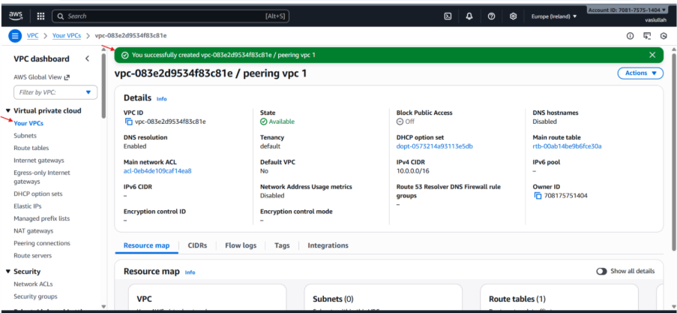

- VPC in N. Virginia region
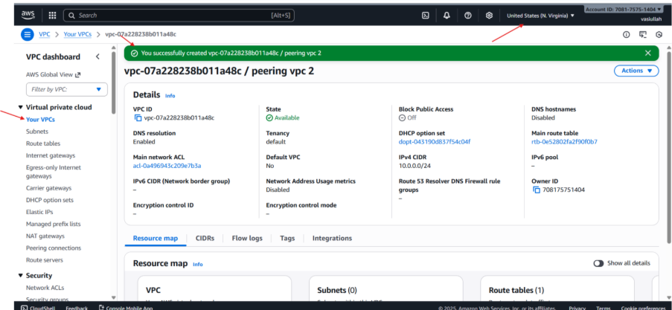

- Create subnet in VPC in the CIDR range.
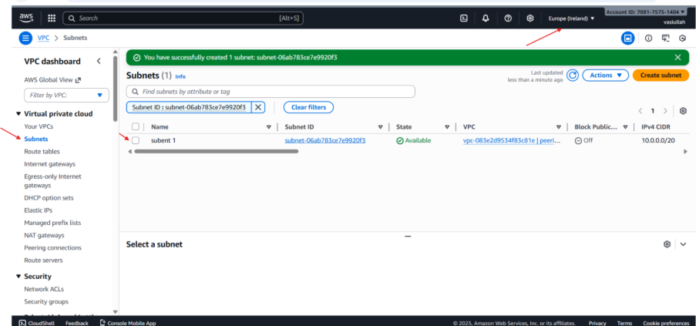

- Create subnet in VPC in the CIDR range.
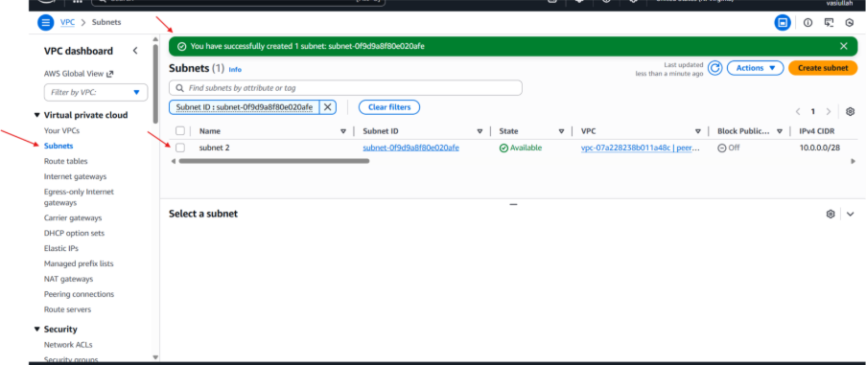
- Go to peering connection in VPC and click on create peering connection and
provide the details of the acceptor VPC ID. And click on save.
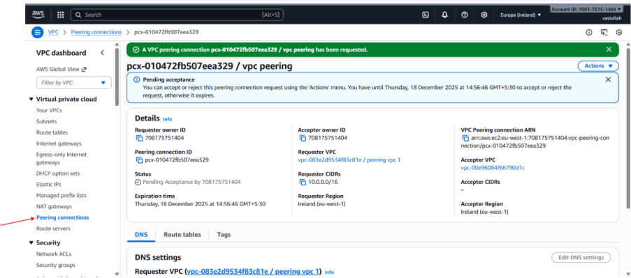

- Now update the route table go to routes and add route. And there we need add
the peering vpc.
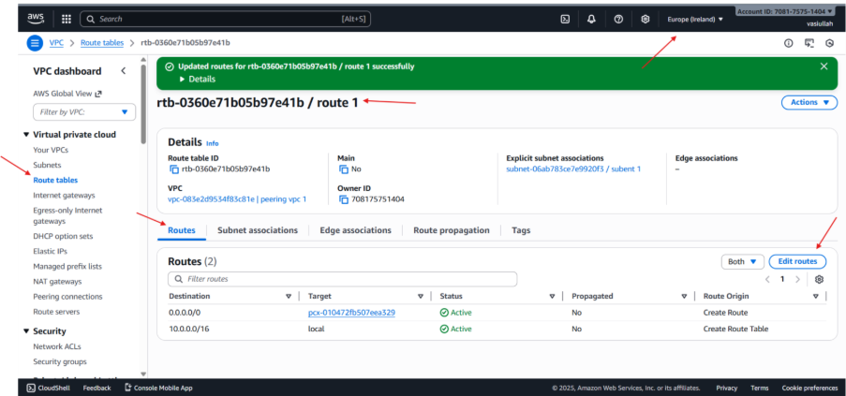
CONCLUSION
After updating the route table the peering will get successful

2. Purchase one domain from GoDadd:
- Open GoDaddy Website
- CloudFront Deployment has been done by using credentials
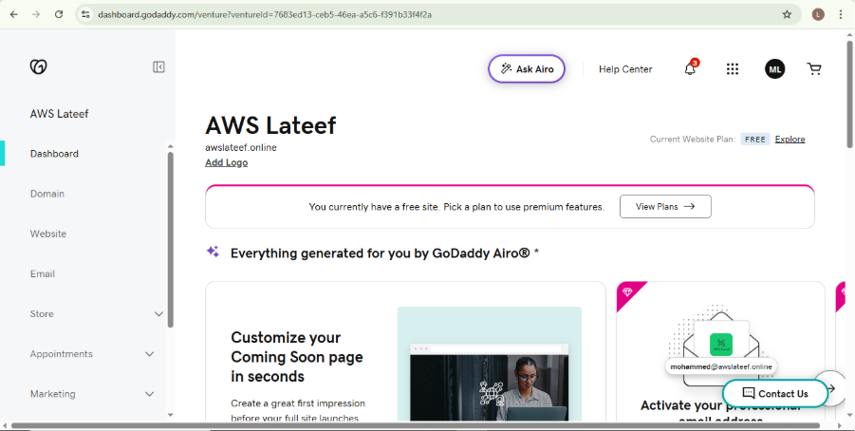

Conclusion:
- By pointing the GoDaddy name servers to AWS Route 53 and using CloudFront as the secure content delivery layer, the static website hosted in the purpose-buckeat S3 bucket is now accessible via the custom domain https://vasifoods.store over a secure HTTPS connection.

3. Deploy static website in S3:
- An active AWS account with necessary S3 permissions (Admin or equivalent).
- A static HTML file to be uploaded (rcb.html).
- The S3 bucket must have public access enabled via permissions and bucket policy.
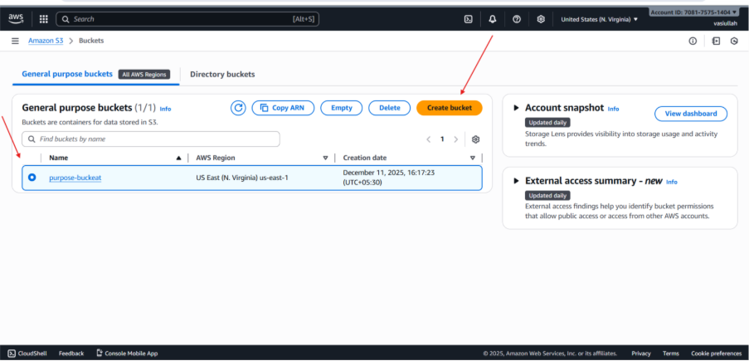
Step-by-Step Implementation
Create the S3 Bucket
- Action: Navigate to the S3 console and click Create bucket.
- Details: The bucket named purpose-buckeat was created.
- Region: The bucket was created in US East (N. Virginia).
Upload the Static File
- Action: Click on the purpose-buckeat bucket and navigate to the Objects tab.
- Action: Upload the HTML file named rcb.html to the bucket.
- Result: The file rcb.html is successfully stored as an object in the bucket.
Enable Static Website Hosting
- Action: (Implicitly performed) Navigate to the Properties tab of the bucket.
- Action: Enable Static website hosting and configure the Index document to be the uploaded file (rcb.html).
Configure Public Access (Bucket Policy)
- Action: (Implicitly performed) Navigate to the Permissions tab.
- Action: Apply a bucket policy to allow s3:GetObject permission for the principal * (everyone) on the bucket resources.
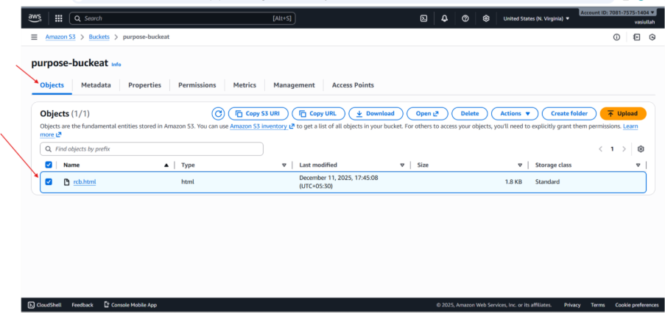
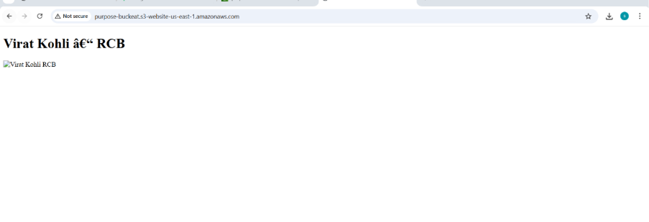
Conclusion:
The core objective of deploying and accessing a static HTML file via S3 Static Website Hosting was successful, as the bucket was created, the file was uploaded, and the endpoint loaded the text content of the HTML file.

4.Create a CDN and attach one SSL certificate:

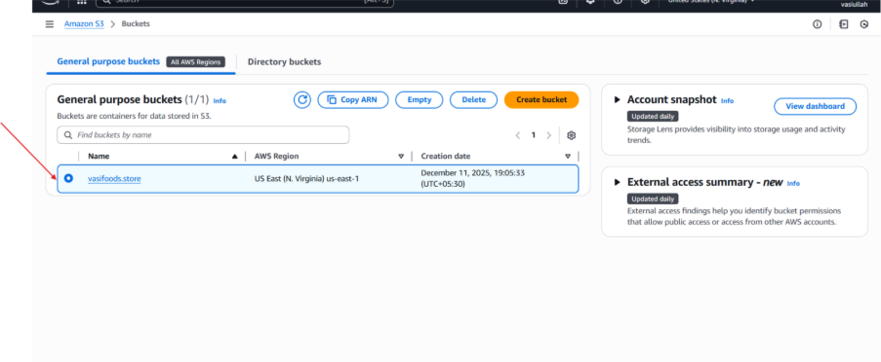
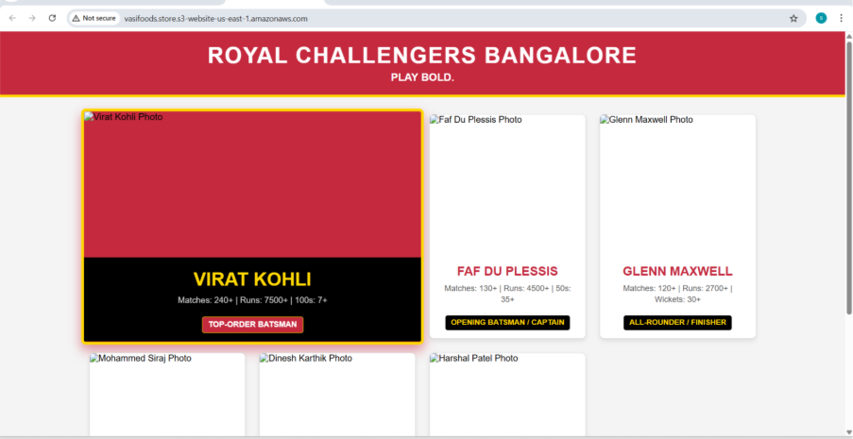

6.Update the index.html in the S3 bucket and ensure the updated file is accessible using the domain name:
- An active AWS Account.
- A basic HTML file (in this case, techie.html).
- Public access permissions configured for the S3 bucket.

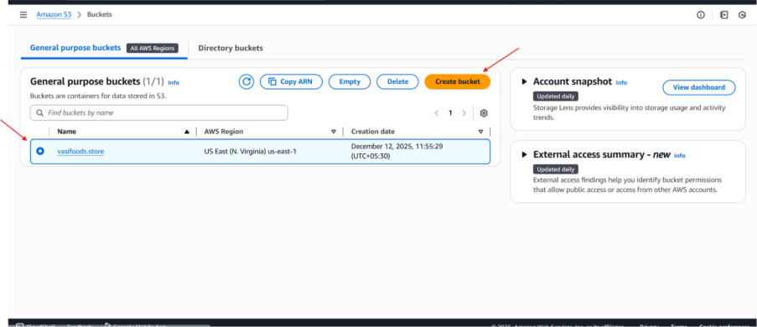
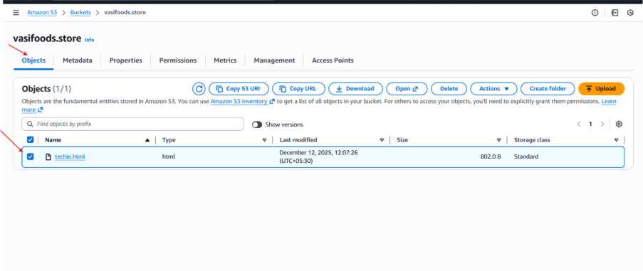
- Step-by-Step Implementation
Create the S3 Bucket
- Navigate to the S3 Console.
- Click Create bucket.
- Bucket Name: vasifoods.store (Note: S3 bucket names must be globally unique).
- Region: US East (N. Virginia) us-east-1.
Upload Website Content
- Open the vasifoods.store bucket.
- Under the Objects tab, click Upload and add your techie.html file.
- Ensure the file is successfully listed in the bucket.
Enable Static Website Hosting
- Go to the Properties tab of the bucket.
- Scroll down to the Static website hosting section and click Edit.
- Select Enable.
- Hosting type: Host a static website.
- Index document: Enter techie.html (or your primary entry file).
- Save changes.
Configure Permissions
- Navigate to the Permissions tab.
- Ensure "Block all public access" is turned OFF to allow the website to be viewed by the public.
- Attach a Bucket Policy to allow s3:GetObject permissions for everyone (*).

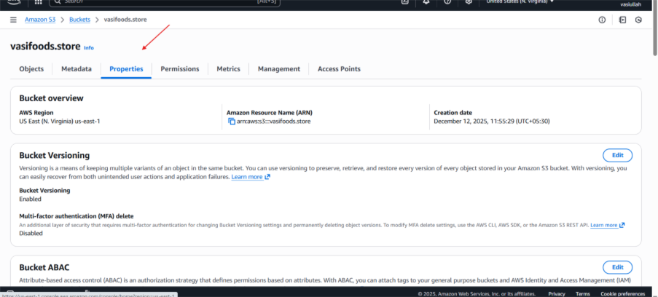
Validation Steps
- Go back to the Properties tab and scroll to the bottom.
- Copy the Bucket website endpoint URL.
- Paste the URL into a web browser.
- Result: The browser should display the "Welcome to TechieHorizon" landing page.

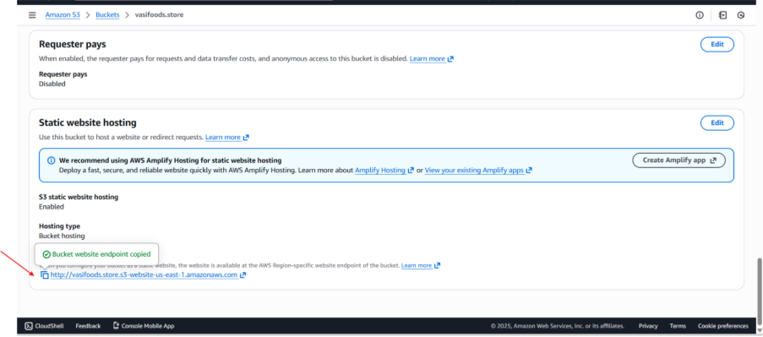
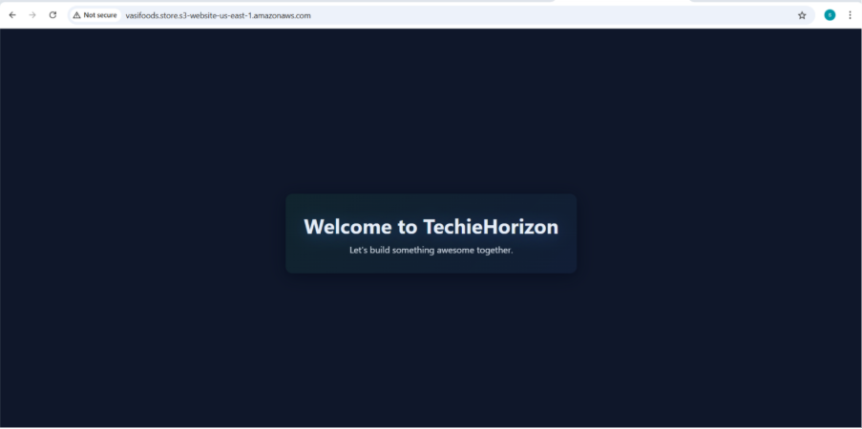
Conclusion
- By utilizing Amazon S3’s static website hosting feature, we have deployed a lightweight, highly scalable, and cost-effective web page. This setup eliminates the need for managing a traditional web server for static content.

